Checkpoints - Nov 2005
Silver Falcons Even though small in number, the 2005 Silver Falcons Reunion was enjoyed by all. Attendees were: Kirk and Jill Brown-Colorado Springs, Colo.; "Chris" and Lil Chrisinger-Winfield, Iowa; Bob and Hilda Dodge-San Diego, Calif.; Chuck and Carol Foster-Albert Lea, Minn.; Pete Graybash-Hershey, Penn.; Jim and Pat Kirkstadt-Johnstown, Penn.; and Ruth Whitaker-Colorado Springs, Colo.
The reunion started Sep. 7, as the early arriving attendees enjoyed an outdoor dinner at America the Beautiful Park listening to a concert presented by the Falconaires of the USAFA Concert Band. Thursday began with a tour of Doolittle Hall, AOG Headquarters, and briefing by Gary Howe, ’69, Vice President for Alumni Relations and Marty Marcolongo, ’88, Constituent Liaison. Part of the group elected to go up to the Cadet Area to watch the noon meal formation before going to the Officer's Club while the rest went to the Officer's Club early. Then if was off to the Visitor's Center for an Admissions Briefing update by the current Director of Enrollment Programs, Lt. Col. Greg Meyers. The group was greeted by Col. "Trapper" Carpenter, ’73, Director of Admissions. The briefing was given there since all the offices in Harmon Hall have been relocated to the Oracle Building on the other side of I-25 until Harmon Hall has been refurbished, which should be sometime in the spring of 2006. Following the briefing, shopping was on store there at the Visitor's Center. That evening, the majority of the group boarded a Ramblin Express bus and headed to Cripple Creek. Unfortunately, nobody came back as a big winner. Friday morning started out with the Silver Falcons working breakfast business meeting. With seven members present, a quorum was established. The group went over the proposed Silver Falcons Affinity Group Charter drafted by Kirk Brown using the previous Silver Falcon Association Constitution and By-Laws as a basis. With just a few minor changes, the group voted to approve the charter which will be sent to the AOG Board of Directors for approval. The charter establishes the offices of President and Vice President for a term of 4 years. By unanimous vote, Kirk Brown was elected President to serve until 2009. Then it was off to the USAFA Library for a tour of the library and Special Exhibits. The one hour tour went for two excellent hours as our tour guide, Dr Ed Scott, Head Librarian, kept us all entertained and informed. We could have gone on for another hour but it was lunch time. We all headed up to the dinning room on the 6th floor of Fairchild Hall over looking the cadet area below. After a quick lunch, it was down to the large lecture hall in Fairchild were we received briefings from the superintendent, commandant, dean, and athletic director. Then back to the hotel to get ready to go to the Flying W Ranch for dinner. Food was great as usual as were the Flying W Wranglers with their western stage show. Saturday morning started off with the AOG/Quarterback Club tailgate party followed by the Falcons defeating the San Diego Aztecs 41-29 under sunny skies. After the game, everybody went to the post-game tailgate for soda or beer and pizza to celebrate the victory and say good-bye to everybody. Plans are already under way for the 2006 Silver Falcons Reunion. Tentative time frame is the first home football game after Labor Day (Parent's Weekend). So mark your calendars now for next year. Hope to see more of you there!
Two members of the Silver Falcons Affinity Group were presented with Lifetime Achievement Awards at the Admissions Conference in Jan 05 for their many years of Admissions Liaison Officer service: Brig. Gen. (Ret.) Dennis Schulstad, Minnesota, for 33 years and Lt. Col. (Ret.) Robert Canfield, Massachusetts, for 30 years.
Now for some administrative announcements. First, everybody who has a listed email address has been sent an email by Kirk Brown. Many of these emails were returned as the account no longer existed. If you have not received an email from Kirk, please send him an email at ltckirkbrown@juno.com so your email address can be updated both in the Silver Falcons Affinity Group and AOG data bases. With out a current email address on file, you are missing our on our primary means of communication as a group and you are not receiving “ZoomiEnews” which is emailed to all AOG members once a month with information about the Academy. The same thing goes for mailing addresses. Please keep both current. Second, we would like to hear from each of you on what is happening in your lives, such as travels, as well as professional and community service. We especially want to be informed of the passing of past or present Silver Falcons. We have always given credit to the deceased members and want to continue to do so. This information will be published in this column. So please email or send postal mail to Kirk at the email address above or to 2539 Craycroft Drive, Colorado Springs, CO, 80920-1423.
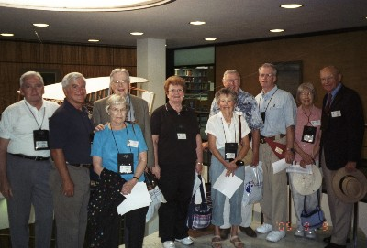
Left To Right: Pete Graybash, Kirk Brown, Chuck & Carol Foster, Pat Kirkstadt, "Chris" & Lil Chrisinger, Jim Kirkstadt, and Bob & Hilda Dodge.
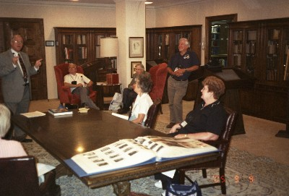
Dr. Ed Scott and Silver Falcons in the Gimbel Collection
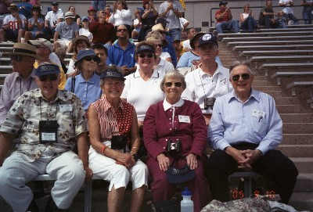
Silver Falcons enjoying the football game

