TRIVIA QUESTION:

Was Brian Duffy the first classmate to wear a spacesuit to work?

Not according to Bill Lyerly…
BILL LYERLY WEARING A “SPACESUIT” IN THE ‘70s

Bill Lyerly is shown wearing a bio-hazard spacesuit made by ILC Dover (the same folks as who make NASA’s spacesuits)

(NOTE: As a cadet, Lyerly worked with the EE and Life Sciences Departments to help design the lower body negative pressure device (to simulate gravity and to study the effects of weightlessness on the human body) for Skylab.

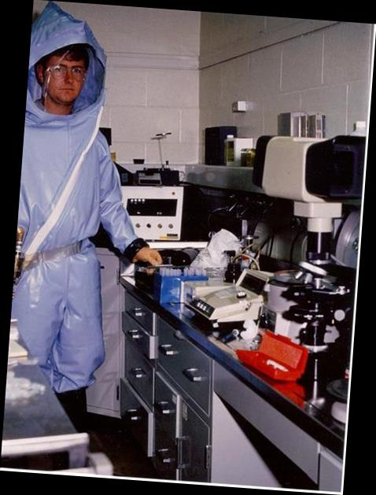  BSL-4 Lab & Space Suit - USAMRIID - Front View | 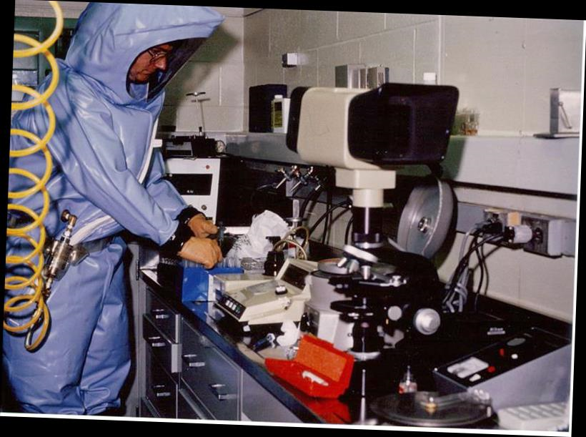  BSL-4 Lab & Space Suit - USAMRIID - Side View
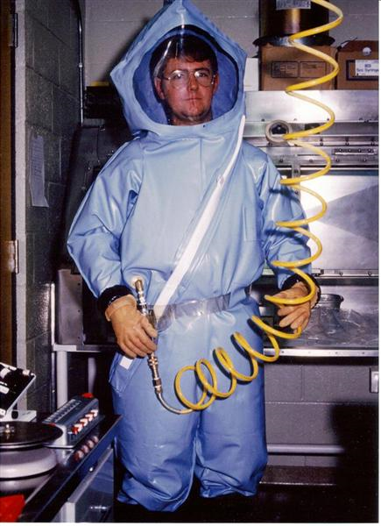  ILC Dover Space Suit – USAMRIID 1 | 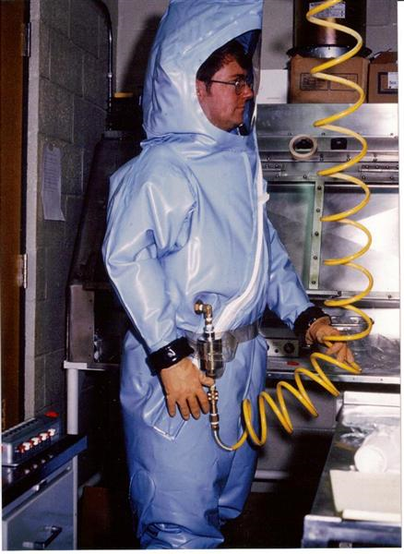  ILC Dover Space Suit - USAMRIID 2

